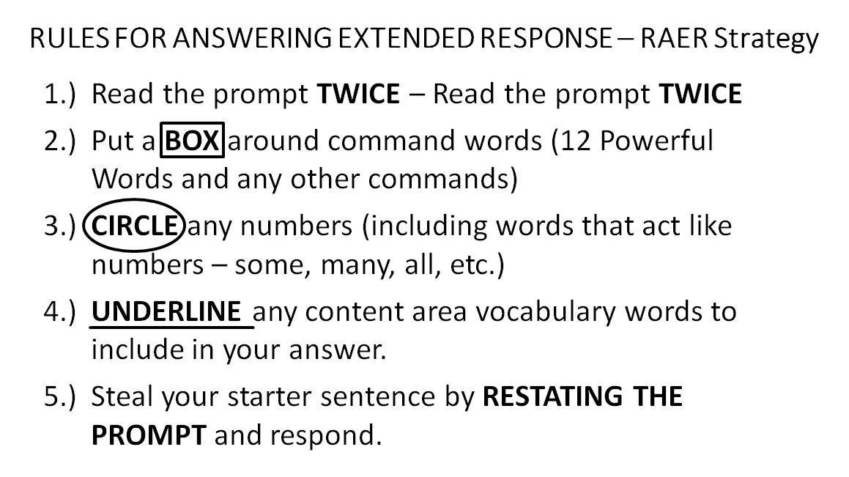

Explain how the speaker’s point of view, or attitude, influences the way that John Snow’s life and work is presented in the poem. Use specific details from the poem “John Snow” to support your answer.
Starter Sentence:
_______________________________________________________________________________________________________________________________________________________________________________________________________________________________________________________________________________________________________________________________________________________________________________________________

